Week 5: 22-26 June 2026
- Dataset Management
This section is about information on total image usage, separation, and randomization.

1.1 Dataset Usage and Separation
Dataset usage
- eXtreme Weather Object Detection (XWOD) dataset is currently the closest traffic-object detection paper to the project I found. It contains 10010 images and 42924 bounding boxes, categorized as car, person, truck, motorcycle, bicycle, and bus. This paper also benchmarks YOLO-family detectors, including YOLO26 family models. [1]
- FishEye8K dataset is also a traffic-camera object detection benchmark, containing 8000 images and 157K bounding boxes, categorized as pedestrian, bike, car, bus, and truck. Its data comes from 18 fisheye traffic cameras. [2]

Dataset separation
- Ultralytics' official YOLO dataset guide recommends a baseline split of 70% train / 15% validation / 15% test. It also states that the validation set is used to select the best epoch, adjust hyperparameters, and compare runs, while the test set should only be used once in the final evaluation. [3]
- A YOLOv5s-based traffic-flow detection study used a Vehicle-10000 dataset with 10 000 images and applied a 70/15/15 training-validation-test split. The model focused on vehicle categories including car, motorcycle, truck, and bus. [13]

Decision item | Selected setting | Detail
Dataset source | MIO-TCD Localization subset | MIO-TCD has 137 743 high-resolution traffic localization images (110 000 ground truth) with traffic-object labels [5]
Total images | 11000 | Similar to XWOD 10010 and FishEye8K 8000 traffic images [1] [2]
Split | 70 / 15 / 15 | Official Ultralytics YOLO recommendation [3]
Train images | 7700 | Used to train YOLO26n weights
Validation images | 1650 | Used for model selection, tuning, pruning/quantization comparison
Test images | 1650 | Locked for final evaluation only
Table 1: Selected Dataset Split of the Project Based on the Literature

Therefore, this project uses a 70/15/15 train/validation/test split, following the Ultralytics YOLO dataset recommendation. The final 11000 image dataset is separated into 7700 training images, 1650 validation images, and 1650 test images. (approximately 70/15/15 image split, while also checking object-level class balance across train, validation, and test sets)

1.2 Datasets Randomization
It is recommended to avoid simple fully random per-image splitting. For traffic camera data, the safest approach is:
- Group by source group.
Priority order: camera ID > scene/location > day/time > original sequence/video.
Purpose: To avoid similar frames appearing simultaneously in both train and validation /test datasets.
- Perform stratified splitting.
Make the class distribution within the train/validation/test dataset as similar as possible; for example, avoid concentrating car, bus, truck, and pedestrian classes in a single set.
- Fix the random seed.
For example, seed=42. This makes the split reproducible, allowing for re-validation of the results in the report.
- Augmentation should only be used on the training set.
Do not perform training augmentation on the validation and test sets; otherwise, the final mAP will not be clean.
- Lock the test set.
The test set should only be used in final evaluation and should not be used to select pruning layers, quantization methods, epochs, or hyperparameters.

Ultralytics specifically points out that random per-image splitting can cause leakage, especially since video/traffic camera frames are highly correlated; a better approach is to split by scene, camera, day, and location. [6]

The FishEye8K paper also uses a similar concept: to avoid bias, it assigns frames from the same camera to either training or testing, rather than mixing them on both sides. [2]

Therefore: Group-aware + stratified + fixed seed
- Avoids camera/scene leakage and keeps class balance

2. Model Optimization Methods
The focus of this week is on optimization methods for YOLO26n, especially quantization and pruning. The goal is to reduce model size, memory usage, and inference latency while keeping the detection accuracy as close as possible to the original FP32 baseline model.

This is important because the final target system is an embedded and FPGA-based traffic detection platform, where computation, memory, and power resources are limited.

2.1 Quantization
Quantization is a model compression method that represents model weights and/or activations using lower-precision numbers. A normal deep learning model usually uses 32-bit floating-point values, called FP32. Quantization converts these values into lower precision formats such as FP16 or INT8. [7] [8]

A simple quantization relationship can be written as:
real value ≈ scale * (quantized integer - zero point)
This means that floating-point values are mapped into a smaller integer range. For example, INT8 uses only 8 bits instead of 32 bits, so the memory needed for weights can be reduced by about 4x compared with FP32. Lower precision can also reduce memory bandwidth and make inference faster on hardware that supports integer arithmetic.

The idea is similar to signal processing. When mapping an analog signal to a digital signal, the number of variables’ decimal places will be reduced:
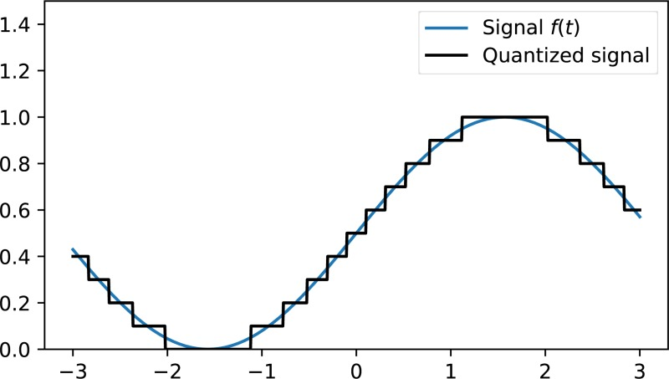
Figure 1: Quantization in Signal Processing

There are two common quantization methods:
- Post-Training Quantization (PTQ)
PTQ applies quantization after the model has already been trained. It is easier and faster to apply because the model does not need to be fully retrained. However, it may cause accuracy loss if the calibration dataset is too small or not representative.
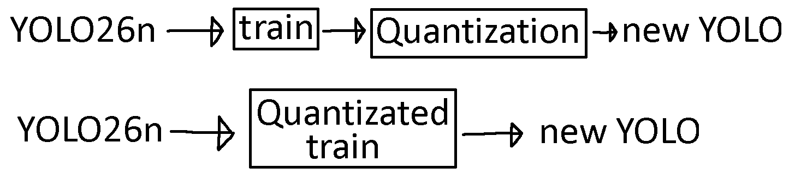
Figure 2: PTQ Process

- Quantization-Aware Training (QAT)
QAT simulates quantization during training or fine-tuning. The model learns to adapt to quantization noise, so it usually gives better accuracy than PTQ, especially for INT8 deployment. However, it requires extra training time.
Figure 3: QAT Process

For this project, PTQ can be used first as a quick experiment because it is simple and fast. If INT8 accuracy drops too much, QAT can be considered as the next step.

2.2 Pruning
Pruning is another model optimization method that removes less important parts of a neural network. The main idea is that not all weights, channels, or filters contribute equally to the final detection result. By removing redundant parts, the model can become smaller and faster. [9]

There are two main types of pruning:
- Unstructured pruning
Unstructured pruning removes individual weights by setting them to zero. This can reduce the number of effective parameters, but it does not always give real inference speedup on normal hardware because the model structure remains the same. It is more useful when the hardware or software framework supports sparse computation.
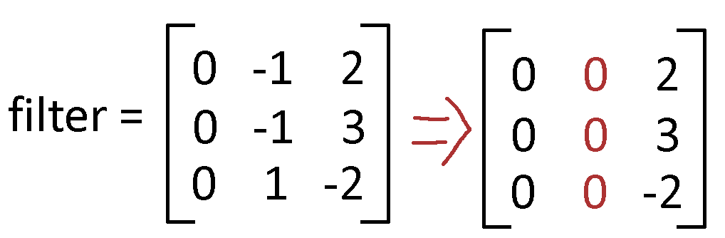
Figure 4: Unstructured Pruning Example

- Structured pruning
Structured pruning removes complete channels, filters, or layers. This directly changes the model architecture and creates a smaller dense network. For embedded deployment and FPGA acceleration, structured pruning is usually more practical because it can reduce actual computation and memory usage. [10]
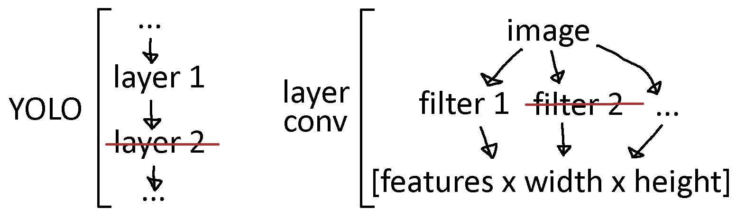
Figure 5: Structured Pruning Example

For YOLO26n, pruning should be applied carefully because different layers have different importance. Early backbone layers extract low-level features such as edges and textures, while later neck and detection layers combine multi-scale object information.

Aggressive pruning on sensitive layers may reduce mAP, especially for small traffic objects such as distant vehicles or pedestrians. Therefore, pruning should be guided by profiling and layer-based sensitivity analysis.

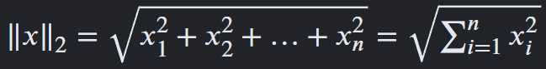
Figure 6: L2-norm

This calculates the straight-line magnitude or "length" of a vector. When performing norm-based filter pruning, finds convolution layers and removes output channels with the lowest L2-norm.
Pavlitska et al. (2024) on YOLOv7 pruning found that selecting filters with the smallest L2-norm achieved better average mAP than L1-norm, random pruning on structured pruning. [11]
This could be one of the directions that we can test.

2.3 Comparison of Quantization and Pruning

Method | Main Idea | Expected Benefit | Main Risk | Suitable Use in This Project
Quantization | Convert higher bit-width data representation into a lower one  (e.g. FP32 to FP16 or INT8) | Smaller model, lower memory use, faster integer inference | Accuracy drop from low precision | First try PTQ; use QAT if accuracy loss is large
Unstructured Pruning | Set individual unimportant weights to zero | Fewer effective parameters | Limited real speedup without sparse hardware support | Useful for analysis, but less ideal for final FPGA deployment
Structured Pruning | Remove channels, filters, or layers | Smaller architecture and real computation reduction | Can damage accuracy if important channels are removed | Best pruning direction for embedded/FPGA deployment
Table 2: Quantization and Pruning Summary

In this stage, pruning is used as an exploration method to identify which layers can tolerate channel reduction.

The PyTorch pruning mask demonstrates the pruning decision, but real deployment speedup may require rebuilding a smaller dense YOLO26n architecture and exporting it again for the target hardware.

2.4 Planned Evaluation
The optimized YOLO26n models should be compared with the original baseline using both accuracy and efficiency metrics. The main accuracy metric should be mAP50-95, while efficiency should be measured using model size, number of parameters, latency, FPS, and memory usage.

A good optimization result should reduce model size and inference latency while keeping the mAP drop small.

3. Experimental Process
Remark: this part is currently in progress; steps will be shown (may modify); the result will be included in the next week.

- First, retain the FP32 YOLO26n baseline: record mAP50-95, model size, latency, and FPS.
- Perform structured pruning exploration: based on profiling and sensitivity results, prioritize modifying layers with low sensitivity and high latency.
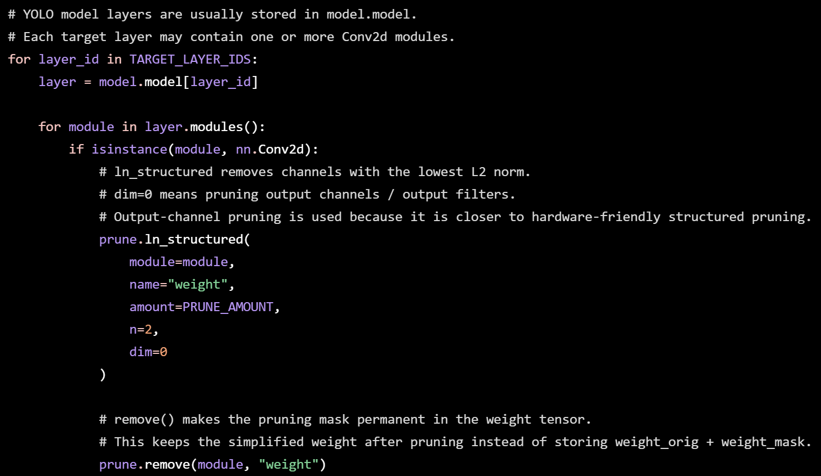
Figure 8: Pruning Exploration

This applies structured pruning to selected YOLO26n layers. For each selected layer, the script finds convolution layers and removes output channels with the lowest L2-norm. The pruning mask is then removed to make the pruned weights permanent. This method is used to explore which layers can be reduced with small accuracy loss.
Later, we will also be removing the layers one-by-one and recording the results.

- Perform INT8 PTQ to observe model size, latency, and accuracy changes.
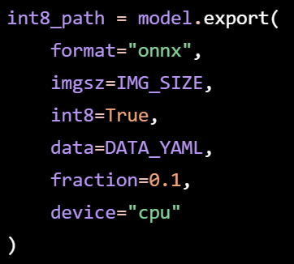
Figure 7: PTQ Export

This exports the original YOLO26n model into INT8 versions. INT8 PTQ converts the model into 8-bit integer representation after training. It requires calibration data from the dataset YAML file to estimate the activation ranges before converting values into 8-bit integers.
Later, we will convert directly from FP32 to INT8 with TFLite [12]

- Compare each version using the same validation/test split: avoid unfair results.
- Finally, summarize in a table: Method / Model size / mAP50-95 / Latency / FPS / Accuracy drop.

References

[1] Chen et al., XWOD: A Real-World Benchmark for Object Detection under Extreme Weather Conditions, 2026. https://arxiv.org/html/2605.11521v1

[2] Gochoo et al., FishEye8K: A Benchmark and Dataset for Fisheye Camera Object Detection, 2023. https://openaccess.thecvf.com/content/CVPR2023W/AICity/html/Gochoo_FishEye8K_A_Benchmark_and_Dataset_for_Fisheye_Camera_Object_Detection_CVPRW_2023_paper.html

[3] Ultralytics, Split the Dataset Correctly, n.d. https://academy.ultralytics.com/courses/dataset-readiness-for-yolo/split-the-dataset-correctly

[4] Ultralytics, Know When the Dataset Is Ready, n.d. https://academy.ultralytics.com/courses/dataset-readiness-for-yolo/dataset-readiness-checklist

[5] MIOvision, MIO-TCD: Localization Challenge Dataset, n.d. https://tcd.miovision.com/challenge/dataset.html

[6] Ultralytics, Split the Dataset Correctly, n.d. https://academy.ultralytics.com/courses/dataset-readiness-for-yolo/split-the-dataset-correctly

[7] Jacob et al., Quantization and Training of Neural Networks for Efficient Integer-Arithmetic-Only Inference, 2017. https://arxiv.org/abs/1712.05877

[8] Subramanian et al., Practical Quantization in PyTorch, 2022. https://pytorch.org/blog/quantization-in-practice/

[9] Han et al., Deep Compression: Compressing Deep Neural Networks with Pruning, Trained Quantization and Huffman Coding, 2015. https://arxiv.org/abs/1510.00149

[10] Cai et al., Structured Pruning is All You Need for Pruning CNNs at Initialization, 2022. https://arxiv.org/abs/2203.02549

[11] Pavlitska et al., Iterative Filter Pruning for Concatenation-based CNN Architectures, 2024. https://arxiv.org/html/2405.03715v1

[12] TensorFlow, Post-training Quantization, 2022. https://www.tensorflow.org/model_optimization/guide/quantization/post_training

[13] Tian et al., Traffic Flow Information Detection under Resource Limitations Based on Framework Optimization, 2026. https://peerj.com/articles/cs-3522.pdf

